**Project 4**

**Modeling and Performance Simulation of 100 MW Solar Linear Fresnel Reflector and Solar Parabolic Trough System**

# Introduction

In recent years due to dwindling natural resources such as coal, crude oil and natural gas, renewable energy resources have been considered to supply the energy demand across the world. Renewable energy systems obtain their energy from renewable resources like wind, geothermal, sunlight, waves and tides. Solar energy is a sort of renewable resources that is abundant across the world. Many technologies (like photovoltaic, solar dish-Stirling, solar power tower, linear Fresnel collector, solar thermal collector, and parabolic trough solar system) have been developed to catch and transform solar energy into thermal and electrical forms of energy. One shortcoming is that the output performance of the solar systems is low. Thermal-based solar systems commonly are combined with a Rankine cycle to produce the electricity. In all solar systems, solar field are considered as boiler for the Rankine cycle. Improving the proficiency of the solar field components can improve the overall yield of the cycle. Optimization methods are concentrated on enhancing the thermal characteristics of heat transfer fluid or improving the geometry of the system [1].

Parabolic trough solar power plant (PTSPP) is a promising technique for converting concentrated solar irradiance into thermic energy. Different methods have been proposed for improving its efficiency. In this project, PTSPP presented in Fig. 1 is designed and simulated for the study region. This simulation is done by System Advisor Model (SAM®) developed by NREL [2]. This designing is divided into three main segments comprising solar field (receiver, mirror, support structure, piping, heat transfer fluid (HTF)), thermal storage (storage HTF, hot tank, cold tank, heat exchanger and pump), and power block (turbine, generator, condenser, pumps and heat exchangers).



Figure 1 A schematic of parabolic trough solar power plant.

The linear Fresnel Reﬂector based CSP power plant is considered as one of the most promising technologies for arid and semi-arid regions. This technology is capable of producing power ranging from few kilowatts (remote power systems) to hundreds of megawatts (grid-connected power plants). Linear Fresnel reﬂector solar thermal power plants (LFRSTPP) mostly consist of a solar ﬁeld and power blocks. TES (thermal energy storage) system can be used to enhance the system potential [4]. Presently installed capacity of CSP plant in India is about 503.5 MW [5]. Simplest application of LFR technology is for the direct steam generation eliminating the need of expensive thermo-oil and complex heat exchangers. The superheated steam can be generated directly in the absorber of the concentrating collector. Schematics of solar ORC are presented in Fig. 1. The organic Rankine cycle process is shown in T–S diagram in Fig. 2. There are four processes in the Rankine cycle.

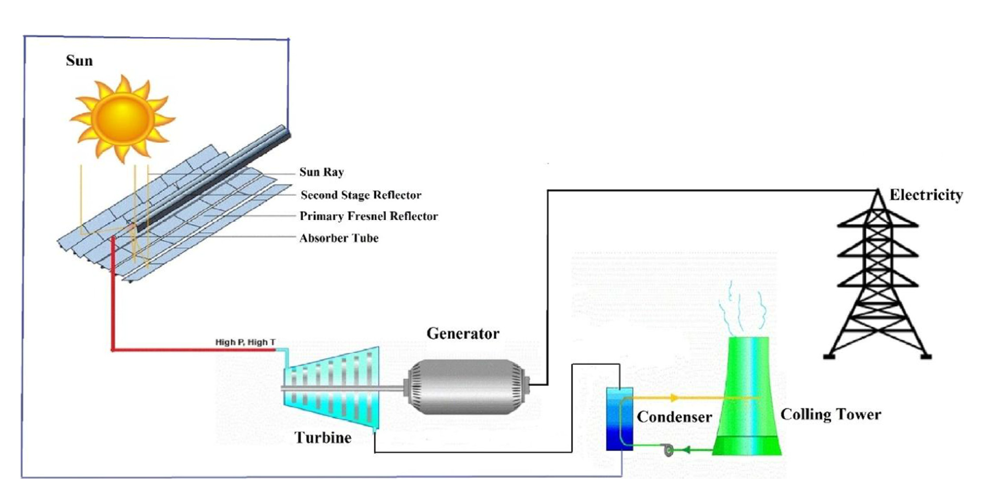

Figure 2 Schematic diagram of Linear Fresnel Solar Thermal Power Plant [3].

# Project Descriptions

Case study: Optional (Suggestions: Spain, United Arab Emirates, United States, India, etc.).

Capacity of the System: 100 MWe

Simulation tool: System Advisor Model (SAM)

# Project content

Project should be presented in the following form:

1. Introduction (regarding energy source, technology and case study) *(10 points)*
2. Case study (Plot: solar radiation, dry bulb temperature and wind speed for the case study region) *(10 points)*
3. Material and methods (a short explanation about each power plant and simulation tool) *(15 points)*
4. Results and discussion ((Summary of energy and economic analysis for each power plant (annual energy, capacity factor, LCOE (nominal), net capital cost)); Efficiency of each power plant (you can discuss the efficiency of each power plant in different sections such as receiver thermal efficiency, field optical efficiency, etc.); System power generated (profile or time series or heat map)) *(30 points)*
5. Conclusions (compare the power plants and discuss the results) *(15 points)*

*Presentation (20 points)*

**References**

[1] N. B. Desai and S. Bandyopadhyay, “Optimization of concentrating solar thermal power plant based on parabolic trough collector,” *J. Clean. Prod.*, vol. 89, pp. 262–271, Feb. 2015.

[2] “System Advisor Model (SAM) |.” [Online]. Available: https://sam.nrel.gov/. [Accessed: 13-Mar-2019].

[3] D. Bishoyi and K. Sudhakar, “Modeling and performance simulation of 100 MW LFR based solar thermal power plant in Udaipur India,” *Resour. Technol.*, vol. 3, no. 4, pp. 365–377, 2017.